**PHASE 3 SUBMISSION**

**PUBLIC TRANSPORTATION EFFICIENCY ANALYSIS**

**IMPLEMENTATION :**

**LOADING AND PREPROCESSING THE DATA :**

%matplotlib inline

import numpy as np # linear algebra

import pandas as pd # data processing, CSV file I/O (e.g. pd.read_csv)

import matplotlib.pyplot as plt

import datetime

import os

from math import sqrt

import warnings

data = pd.read_csv('../input/unisys/ptsboardingsummary/20140711.CSV')

data.shape

data.head(10)

**OUTPUT :**

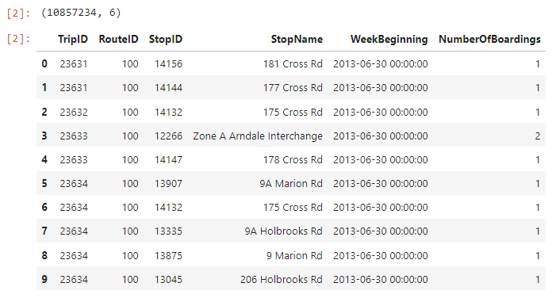

out_geo = pd.read_csv('../input/outgeo/output_geo.csv')

out_geo.shape

out_geo.head()

**OUTPUT :**

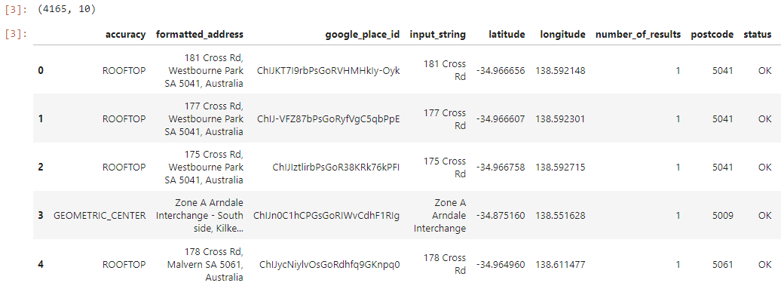

#DistanceFromCentre: Distance measure from the city centre

#For Calculating Distance between centre with other bus stops by using Longitude and Latitude

#we have used the Haversine formula

from math import sin, cos, sqrt, atan2, radians

def calc_dist(lat1,lon1):

## approximate radius of earth in km

R = 6373.0

dlon = radians(138.604801) - radians(lon1)

dlat = radians(-34.921247) - radians(lat1)

a = sin(dlat / 2)**2 + cos(radians(lat1)) * cos(radians(-34.921247)) * sin(dlon / 2)**2

c = 2 * atan2(sqrt(a), sqrt(1 - a))

return R * c

out_geo['dist_from_centre'] = out_geo[['latitude','longitude']].apply(lambda x: calc_dist(*x), axis=1)

**OUTPUT :**

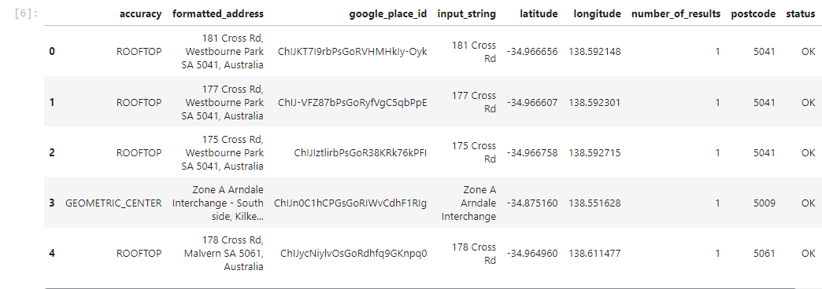

#exp_data = out_geo.head(10)

##Fill the missing values with mode

out_geo['type'].fillna('street_address',inplace=True)

out_geo['type'] = out_geo['type'].apply(lambda x: str(x).split(',')[-1])

out_geo['type'].unique()

**OUTPUT :**

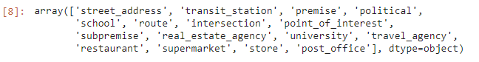

#Combine the Geolocation and main input file to get final Output File.

data= pd.merge(data,out_geo,how='left',left_on = 'StopName',right_on = 'input_string')

data.head(5)

data.shape

**OUTPUT :**

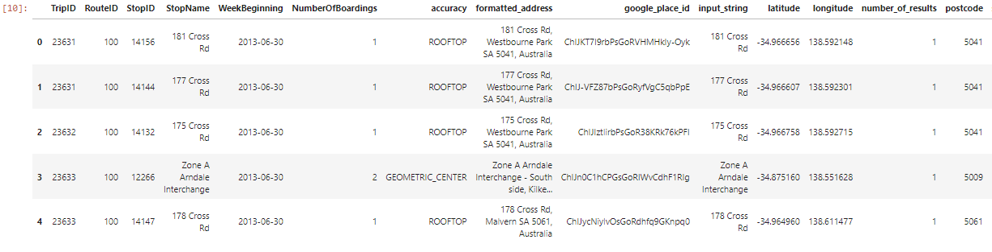



#Columns to keep for further analysis

col = ['TripID', 'RouteID', 'StopID', 'StopName', 'WeekBeginning','NumberOfBoardings',

'latitude', 'longitude','postcode','type','dist_from_centre']

data = data[col]

grouped = data.groupby(['StopName','WeekBeginning','type'])

#grouped.head()

# st_week_grp1 = pd.DataFrame(data.groupby(['StopName','WeekBeginning','type']).agg({'NumberOfBoardings': ['sum', 'count']})).reset_index()

grouped = data.groupby(['StopName','WeekBeginning','type']).agg({'NumberOfBoardings': ['sum', 'count','max']})

grouped.columns = ["_".join(x) for x in grouped.columns.ravel()]

grouped.head(10)

grouped.columns

**OUTPUT :**

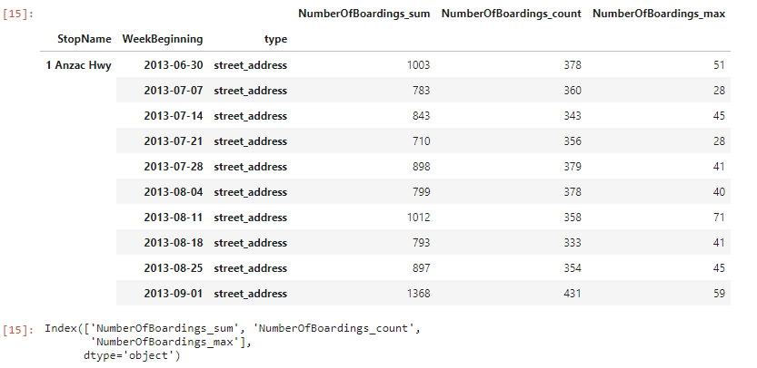

st_week_grp = pd.DataFrame(grouped).reset_index()

st_week_grp.shape

st_week_grp.head()

**OUTPUT :**

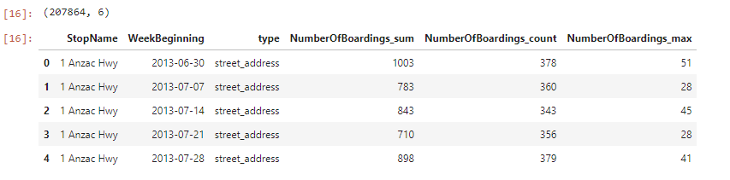

st_week_grp1 = pd.DataFrame(st_week_grp.groupby('StopName')["WeekBeginning"].count()).reset_index()

st_week_grp1.head()

**OUTPUT :**

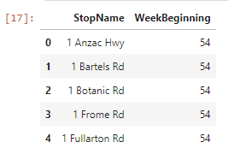

#Gathering only the Stop Name which having all 54 weeks of Dat

aa = list(st_week_grp1[st_week_grp1['WeekBeginning'] == 54]['StopName'])

Aa[1:10]

**OUTPUT :**

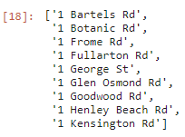

bb = st_week_grp[st_week_grp['StopName'].isin(aa)]

bb.head()

bb.shape

**OUTPUT :**

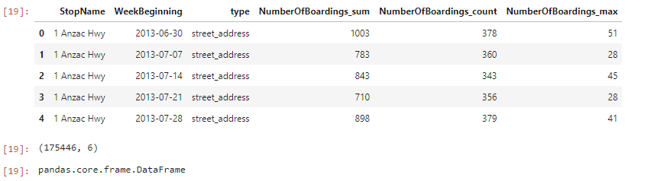

#removing the stoppage which are not having the data of whole 54 weeks

new_data = data[data['StopName'].isin(aa)]

new_data.shape

print("data without stopage removing: ", data.shape)

print("data, after removing stoppage not having the data of whole 54 weeks: ", new_data.shape)

**OUTPUT :**

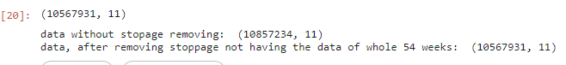

new_data.head(2)

filtered_data = new_data[new_data['dist_from_centre'] <= 100]

filtered_data.shape

**OUTPUT :**

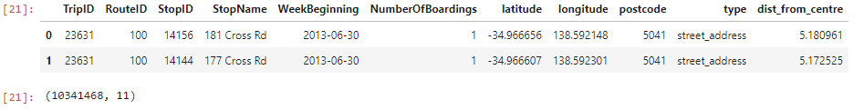

data = filtered_data.copy()

data.shape

**OUTPUT :**



stopageName_with_boarding = bb.groupby(['StopName']).agg({'NumberOfBoardings_sum': ['sum']})

stopageName_with_boarding = pd.DataFrame(stopageName_with_boarding.reset_index())

#type(stopageName_with_boarding)

stopageName_with_boarding.columns = ["StopName", "Total_boarding_on_the_stopage"]

#stopageName_with_boarding.shape

stopageName_with_boarding.head()

**OUTPUT :**

